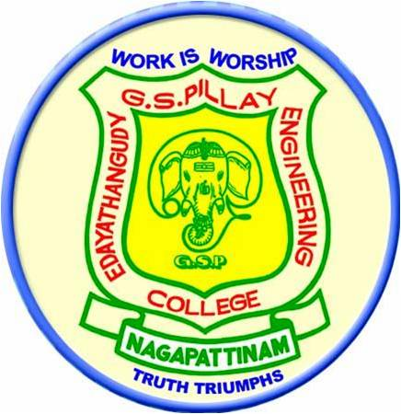

A STUDY ON MANAGEMENT PROCESS IN KIRAN GLOBAL CHEMS LIMITED AT MELAVANJOOR, KARAIKAL
By
M. ANUSHA
(Reg. No: 820813631003)
OF
EDAYATHANGUDY G.S.PILLAY ENGINEERING COLLEGE
NAGAPATTINAM

A SUMMER TRAINING REPORT

Submitted to the
FACULTY OF MANAGEMENT SCIENCES
In partial fulfillment of the requirements
For the award of the degree of
MASTER OF BUSINESS ADMINISTRATION

ANNA UNIVERSITY

CHENNAI – 600 025
JUNE, 2014
BONAFIDE CERTIFICATE

Certified that this project report titled “A STUDY ON MANAGEMENT PROCESS” is the bonafide work of Ms. M. Anusha, Registration Number: 820813631003 who carried out the research under my supervision. Certified further, that to the best of my knowledge the work reported here in does not form part of any other summer training report on the basis of which a degree or award was conferred on an earlier occasion on their or any other candidate.

I. ARUL EDISON ANTHONY RAJ Dr. R. KARTHI Internal Guide Director

E.G.S. PILLAY ENGINEERING COLLEGE, NAGAPATTINAM
DEPARTMENT OF MANAGEMENT STUDIES
SUMMER TRAINING REPORT
CHRONOLOGICAL DIARY
STUDENT NAME :
REGISTER NO :
Date | Managerial Skills Learned | No. of Hours attended | Company In-charge Signature
 | FIRST WEEK
 | SECOND WEEK
 | THIRD WEEK
 | FOURTH WEEK
 | TOTAL NO. OF HOURS ATTENDED

Company In-charge signature with seal

